OWASP BWA Installation

First you need to download the vmware file from:

<https://sourceforge.net/projects/owaspbwa/files/>

By clicking download latest version it will redirect you to a page just wait for the download to begin.

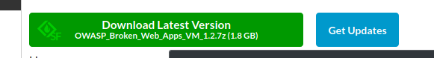

When it ask you save the file.

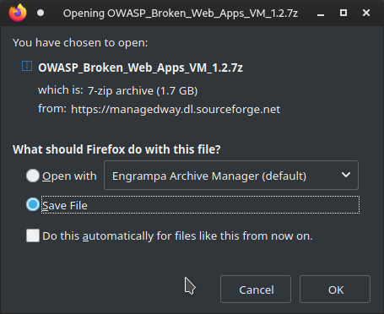

Wait for it to download. Once it is downloaded extract the file .(on most OS’s this can be done by right clicking and selecting extract here)

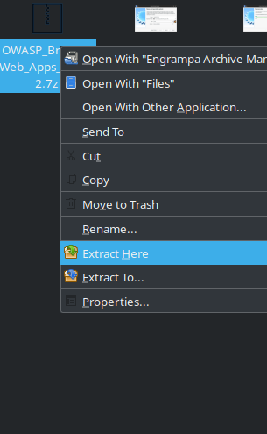

Once Extract is finished open up virtual box and click the new button to set up the vm



Name it OWASP BWA and give it the type linux ubuntu 64 bit. Then click next.

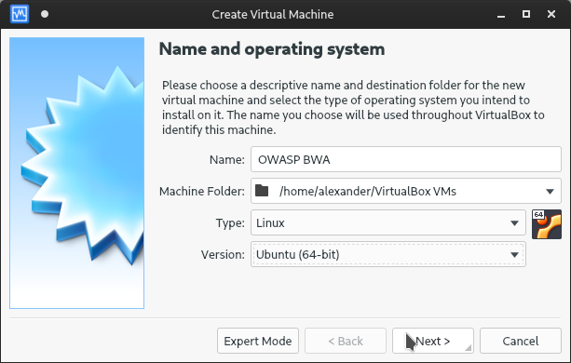

For the next screen the default 1gb of ram is fine click next.

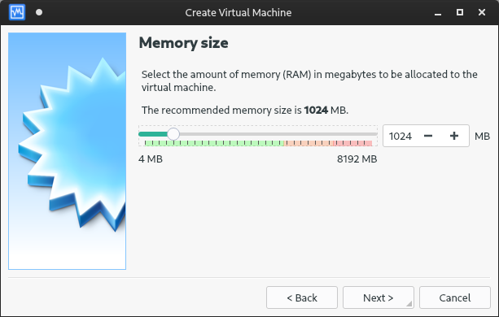

On the next screen choose use existing hard disk file and click the folder with the green arrow

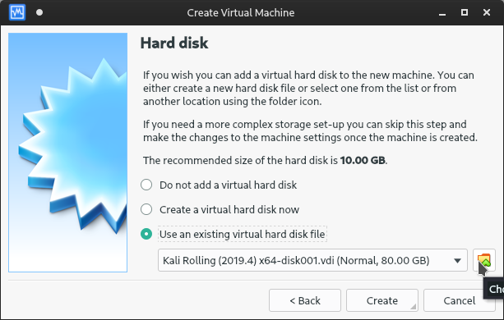

Then click the disk with the green cross to add new disk image

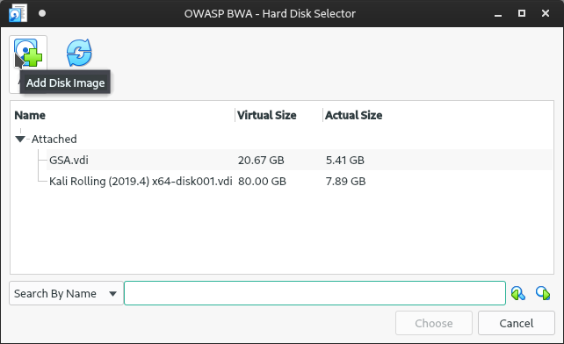

Navigate to the folder where you extracted the File you downloaded it should look similar to this

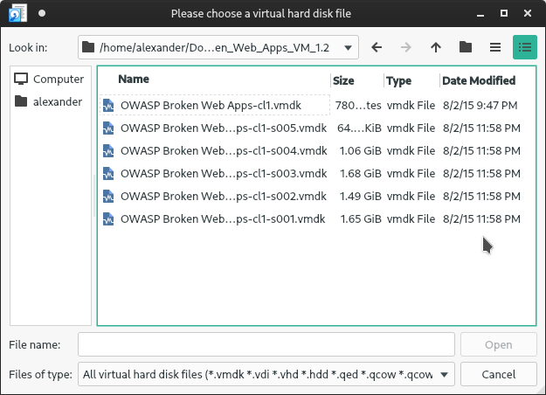

You want to select the one that says OWASP Broken Web Apps-cl1.vdmk **Not any of the ones with S00(X)**. Then click open.

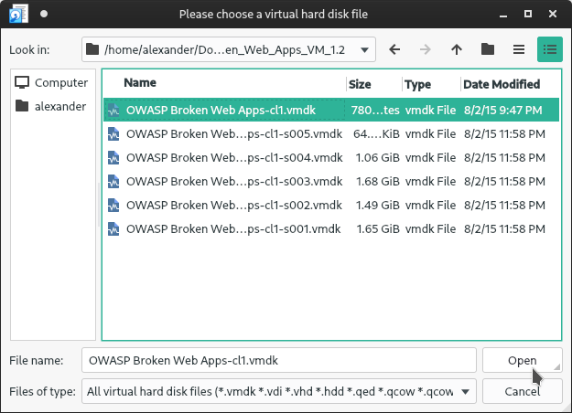

Next choose the same from the list of drives it will be in the unattached section

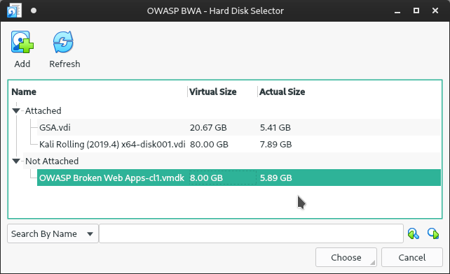

Then click the create button.

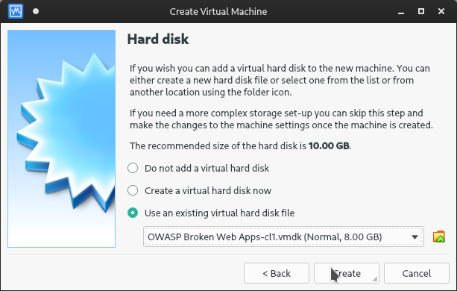

Next click on the vm and click the settings gear

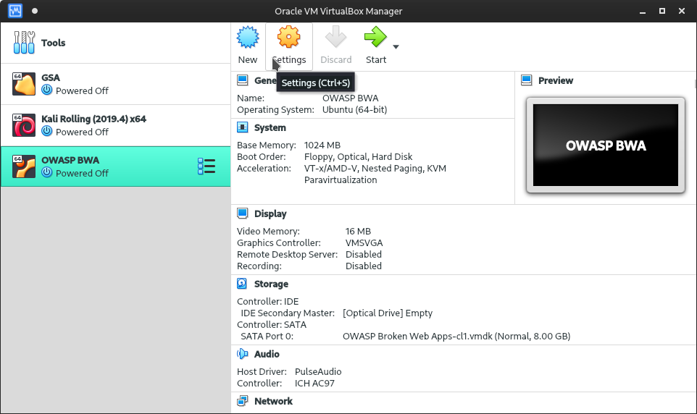

Next click on the network tab

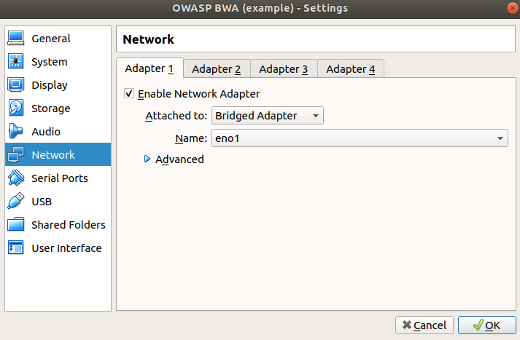

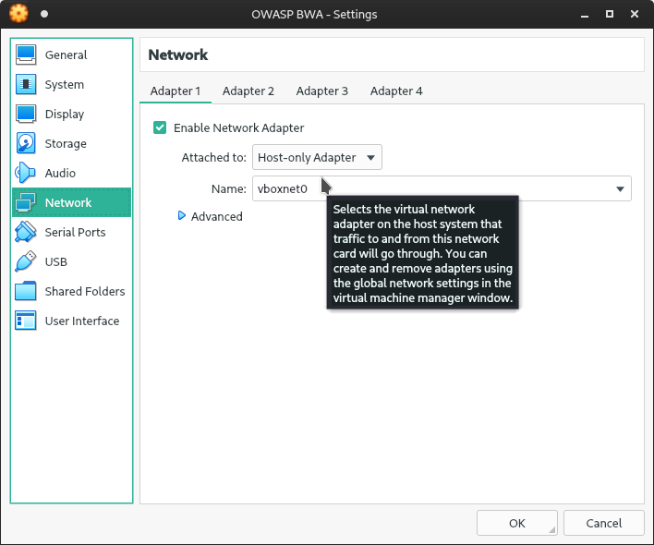

So our lab can see it you need to set it to bridged mode but make sure you set it to the private network and not the western network.